**SQL Server Advanced 10**

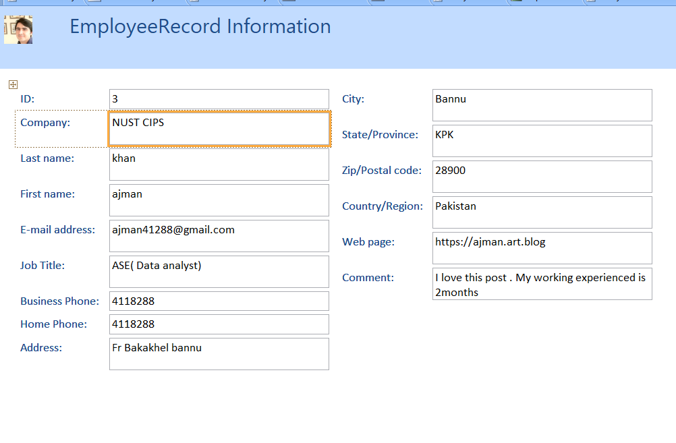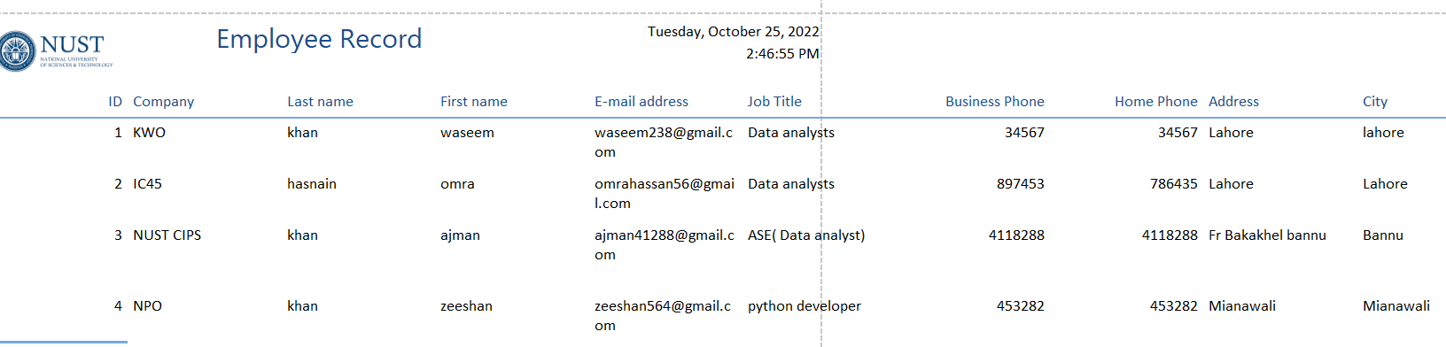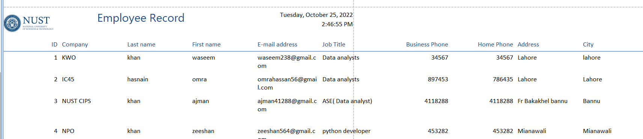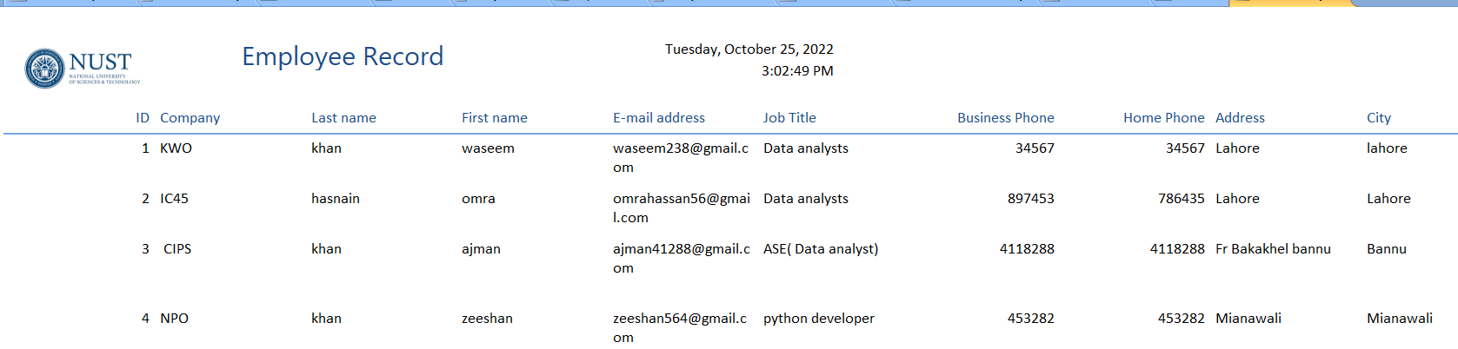

# **Database Architecture in DBMS: 1-Tier, 2-Tier and 3-Tier**

<https://www.guru99.com/dbms-architecture.html>

## **What is Database Architecture?**

A ****Database Architecture**** is a representation of DBMS design. It helps to design, develop, implement, and maintain the database management system. A DBMS architecture allows dividing the database system into individual components that can be independently modified, changed, replaced, and altered. It also helps to understand the components of a database.

A [Database](https://www.guru99.com/introduction-to-database-sql.html) stores critical information and helps access data quickly and securely. Therefore, selecting the correct Architecture of DBMS helps in easy and efficient data management.

* [Types of DBMS Architecture](https://www.guru99.com/dbms-architecture.html" \l "1)
* [1-Tier Architecture](https://www.guru99.com/dbms-architecture.html" \l "2)
* [2-Tier Architecture](https://www.guru99.com/dbms-architecture.html" \l "3)
* [3-Tier Architecture](https://www.guru99.com/dbms-architecture.html" \l "4)

## **Types of DBMS Architecture**

There are mainly three types of DBMS architecture:

* One Tier Architecture (Single Tier Architecture)
* Two Tier Architecture
* Three Tier Architecture

## **1-Tier Architecture**

****1 Tier Architecture**** in DBMS is the simplest architecture of Database in which the client, server, and Database all reside on the same machine. A simple one tier architecture example would be anytime you install a Database in your system and access it to practice SQL queries. But such architecture is rarely used in production.

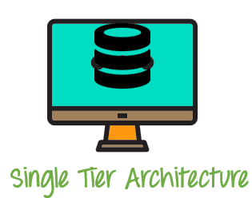

1 Tier Architecture Diagram

## **2-Tier Architecture**

A ****2 Tier Architecture**** in DBMS is a Database architecture where the presentation layer runs on a client (PC, Mobile, Tablet, etc.), and data is stored on a server called the second tier. Two tier architecture provides added security to the DBMS as it is not exposed to the end-user directly. It also provides direct and faster communication.

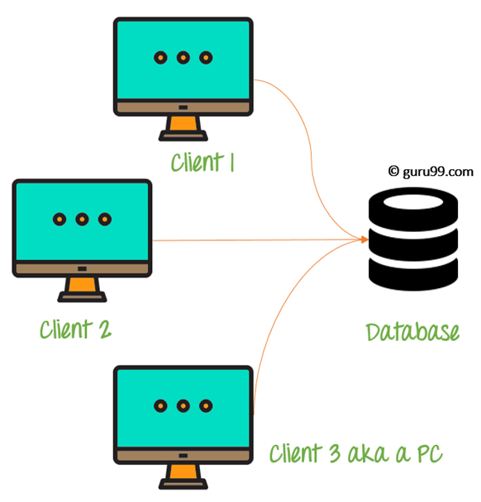

2 Tier Architecture Diagram

In the above 2 Tier client-server architecture of database management system, we can see that one server is connected with clients 1, 2, and 3.

****Two Tier Architecture Example:****

A Contact Management System created using MS- Access.

## **3-Tier Architecture**

A ****3 Tier Architecture**** in DBMS is the most popular client server architecture in DBMS in which the development and maintenance of functional processes, logic, data access, data storage, and user interface is done independently as separate modules. Three Tier architecture contains a presentation layer, an application layer, and a database server.

3-Tier database Architecture design is an extension of the 2-tier client-server architecture. A 3-tier architecture has the following layers:

1. Presentation layer (your PC, Tablet, Mobile, etc.)
2. Application layer (server)
3. Database Server

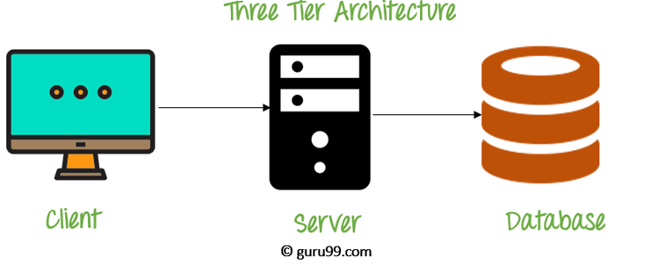

3 Tier Architecture Diagram

The Application layer resides between the user and the DBMS, which is responsible for communicating the user’s request to the DBMS system and send the response from the DBMS to the user. The application layer(business logic layer) also processes functional logic, constraint, and rules before passing data to the user or down to the DBMS.

### **The goal of Three Tier client-server architecture is:**

* To separate the user applications and physical database
* To support DBMS characteristics
* Program-data independence
* Supporting multiple views of the data

****Three Tier Architecture Example:****

Any large website on the internet, including ****guru99.com****.

## **Summary**

* An Architecture of DBMS helps in design, development, implementation, and maintenance of a database
* The simplest database system architecture is 1 tier where the Client, Server, and Database all reside on the same machine
* A two-tier architecture is a database architecture in DBMS where presentation layer runs on a client and data is stored on a server
* Three-tier client-server architecture consists of the Presentation layer (PC, Tablet, Mobile, etc.), Application layer (server) and Database Server

## **3-Tier Architecture**

A ****3 Tier Architecture**** in DBMS is the most popular client server architecture in DBMS in which the development and maintenance of functional processes, logic, data access, data storage, and user interface is done independently as separate modules. Three Tier architecture contains a presentation layer, an application layer, and a database server.

3-Tier database Architecture design is an extension of the 2-tier client-server architecture. A 3-tier architecture has the following layers:

1. Presentation layer (your PC, Tablet, Mobile, etc.)
2. Application layer (server)
3. Database Server



3 Tier Architecture Diagram

The Application layer resides between the user and the DBMS, which is responsible for communicating the user’s request to the DBMS system and send the response from the DBMS to the user. The application layer(business logic layer) also processes functional logic, constraint, and rules before passing data to the user or down to the DBMS.

### **The goal of Three Tier client-server architecture is:**

* To separate the user applications and physical database
* To support DBMS characteristics
* Program-data independence
* Supporting multiple views of the data

****Three Tier Architecture Example:****

Any large website on the internet, including ****guru99.com****.

## **Summary**

* An Architecture of DBMS helps in design, development, implementation, and maintenance of a database
* The simplest database system architecture is 1 tier where the Client, Server, and Database all reside on the same machine
* A two-tier architecture is a database architecture in DBMS where presentation layer runs on a client and data is stored on a server
* Three-tier client-server architecture consists of the Presentation layer (PC, Tablet, Mobile, etc.), Application layer (server) and Database Server

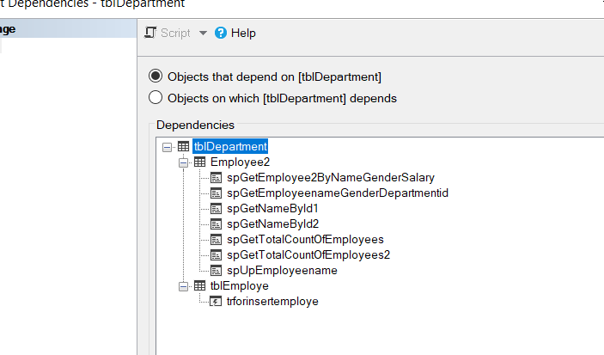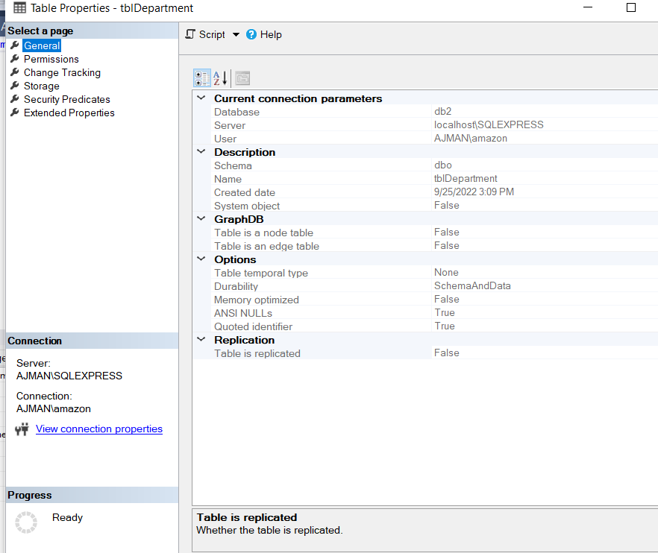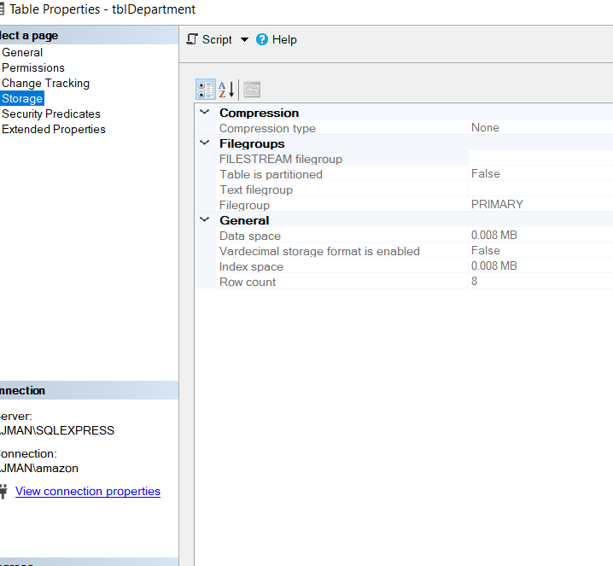

# SQL Server Management Studio (SSMS)

SQL Server Management Studio is a free multipurpose integrated tool to access, develop, administer, and manage SQL Server databases, Azure SQL Databases, and Azure Synapse Analytics. SSMS allows you to manage SQL Server using a graphical interface.

SSMS can also be used to access, configure, manage & administer Analysis services, Reporting services, & Integration services.

SSMS runs only on Windows. Use [Azure Data Studio](https://docs.microsoft.com/en-us/sql/azure-data-studio/download-azure-data-studio?view=sql-server-ver15" \t "https://www.tutorialsteacher.com/sqlserver/_blank) to run on your macOS or Linux (and also Windows). [Install SQL Server Management Studio](https://www.tutorialsteacher.com/sqlserver/install-sql-server" \l "install-ssms) if you have not installed it yet.

To launch SSMS from the Start menu, click Start and scroll down and expand Microsoft SQL Server Tools 18. Click on Microsoft SQL Server Management Studio.

Select Server Type, Server Name, and Authentication mode to connect with your server. SSMS can be used to connect with Database Engine, Analysis Services, Reporting Services, Integration Services, etc. Here, we will connect with our local SQL Server database, so select Database Engine as a server type.

Next, select the server name to which you want to connect. It can be a local or remote DB server. Select an appropriate server name or <Browse for more..> to browse server name.

## SSMS Components

SQL Server Management Studio has the following components:

* Object Explorer
* Security
* Server Objects
* Query and Text Editor
* Template Explorer
* Solution Explorer
* Visual Database Tools

## Object Explorer

Object Explorer contains different components of one or more instances of SQL Server in a hierarchical manner. You can view and manage components such as Databases, Security, Server Objects, Replication, Polybase, Management, etc. Expand the component node to see further objects.

For example, expand the Databases folder to see all the databases available in the server instance. Any new database you create will be available here. There is a default System databases folder, which hosts four default databases: master, model, msdb and tempdb.

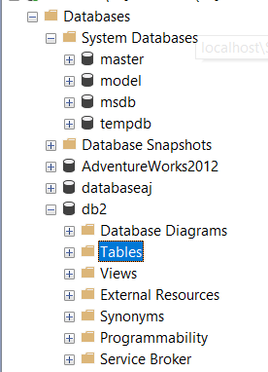

## Security

Managing security for your database server is extremely important. The Security node is below the Databases node in the Object Explorer. You can create Logins and assign Server roles for any database instance. In addition, you can assign role-based security to logins and users. The Server roles you create here have server-wide scope.

## Replication

Replication is a set of technologies for copying and distributing data and database objects between databases and synchronizing databases. This is mainly used for maintaining consistency between databases.

## Polybase

Polybase allows your SQL Server to query directly from other SQL Server, Oracle, MongoDB, Hadoop clusters, Teradata, Cosmos DB by installing client connection software using T-SQL separately. Polybase is used for data virtualization.

## Query and Text Editor

Open a query editor by clicking on the **New Query** on the tool bar. Query editor lets you create, edit & execute Transact SQL (T-SQL) statements. It is equipped with IntelliSense support by auto-completing the script by suggesting variants. This makes writing & debugging code easier and faster.

[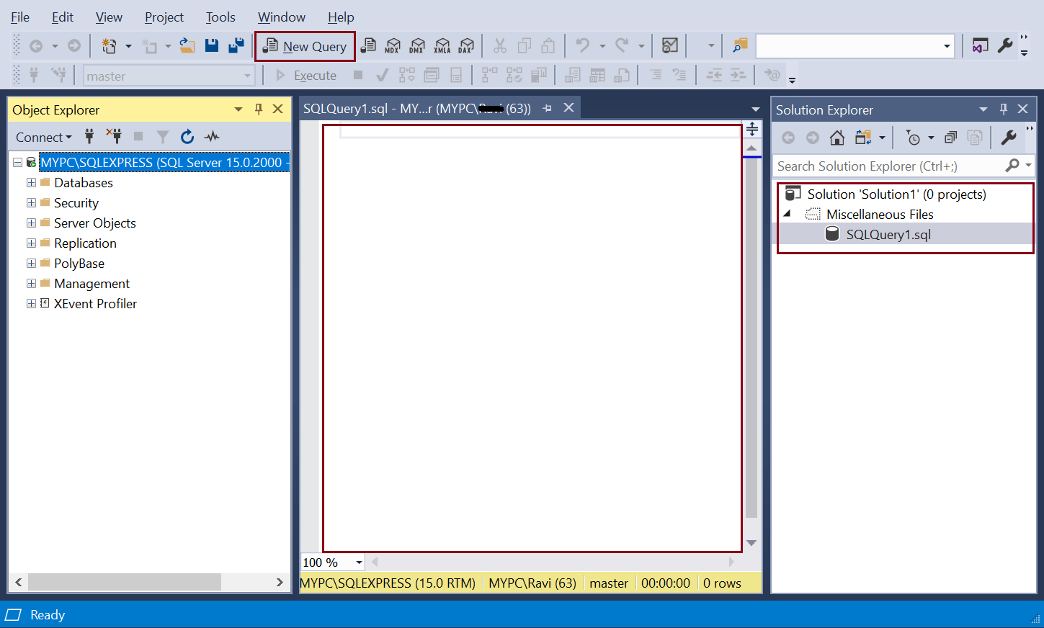](https://www.tutorialsteacher.com/Content/images/sqlserver/SSMS4.png)Query Editor

## Template Explorer

Template explorer provides templates for creating various database objects. You can browse the available templates in Template Explorer and open it into a code editor window. You can also create your own custom templates.

Open Template Explorer from View menu -> Template Explorer. The following displays Create Database template.

[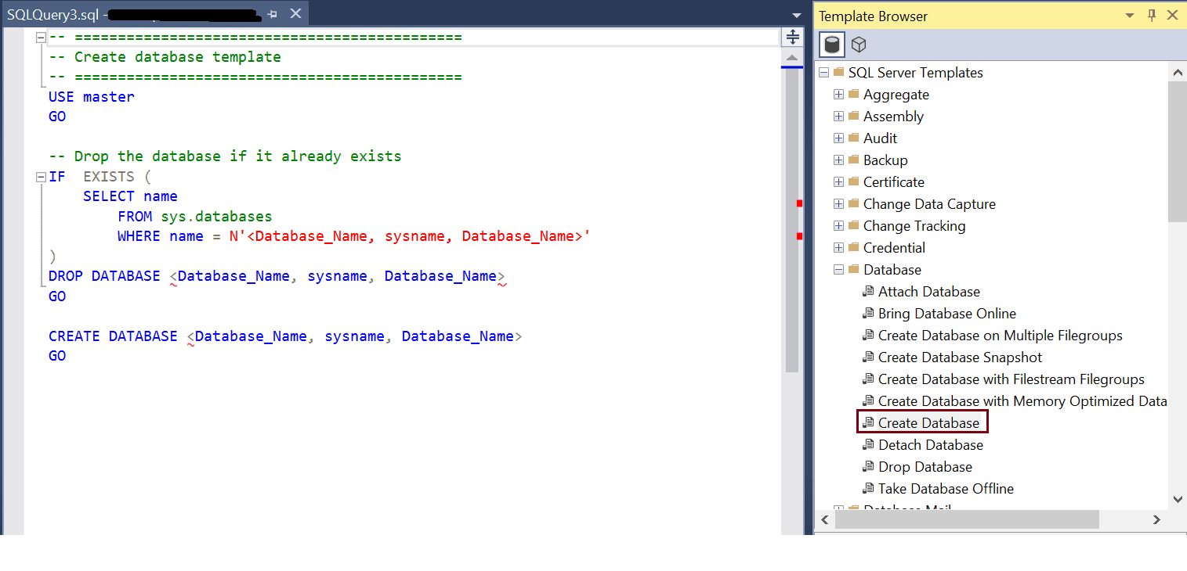](https://www.tutorialsteacher.com/Content/images/sqlserver/SSMS10.png)Template Explorer

## Solution Explorer

Solution explorer is used to manage administration items such as scripts and queries. Open it from View -> Solution Explorer menu.

[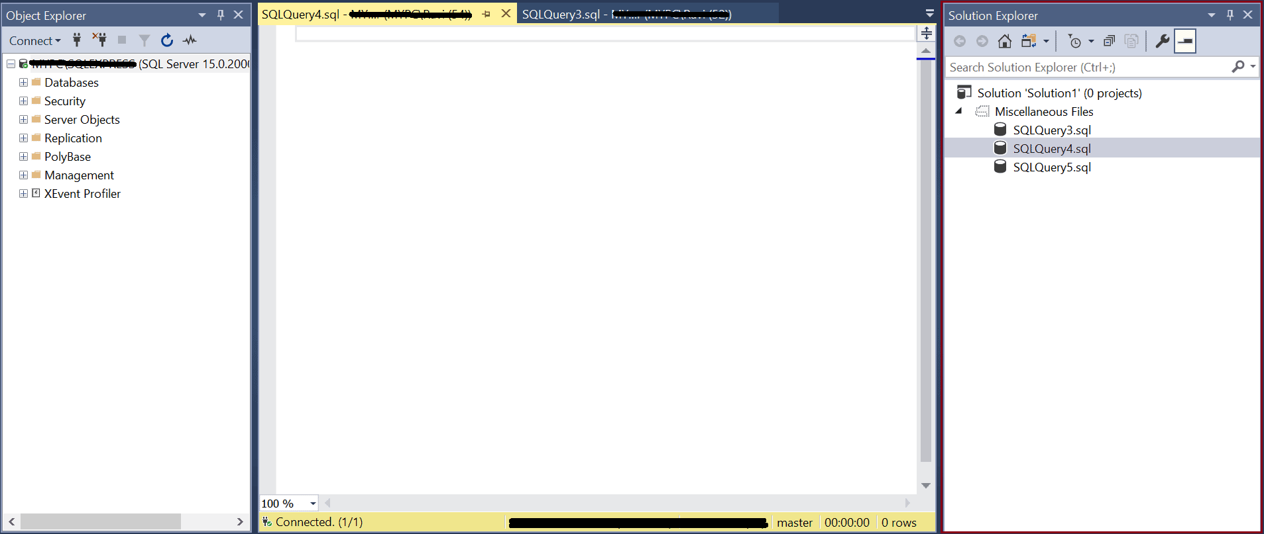](https://www.tutorialsteacher.com/Content/images/sqlserver/ssms11.png)

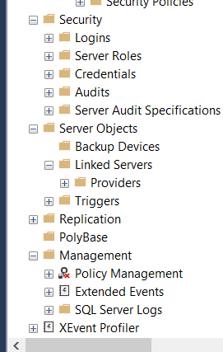

**Important links:**

**<https://www.tutorialsteacher.com/sqlserver/sql-server-management-studio>**

**<https://www.tutorialsteacher.com/sqlserver/windows-authentication>**

# SQL Server Authentication

In the previous chapter, you learned about creating a login using Windows user account. Here, you will learn to create a login using SQL Server user.

At the time of installing SQL Server, if you select Mixed Mode, then you must provide a password for the built-in System Administrator or sa account. It is highly recommended to create a strong password for the sa account; otherwise disable this account as it is mapped to the sysadmin server role and has administrative rights on the whole server. Hence it is vulnerable to attack by hackers.

## Create a New Login with SQL Server Authentication

The login created using SQL Server authentication mode is independent of Windows user accounts. Login and password are created and stored in the syslogins table in the master database. Passwords are not stored as plain text.

To create a new login using SQL Server authentication, follow the steps:

Open SQL Server Management Studio. In the object explorer, expand the Security node. and right-click on the Logins node and select New Login.

[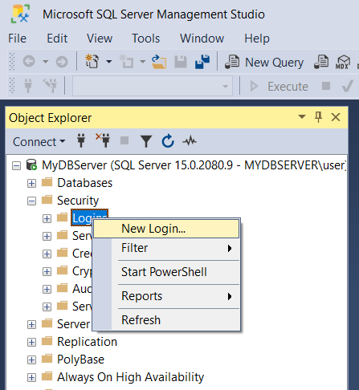](https://www.tutorialsteacher.com/Content/images/sqlserver/authentication2.png)SQL Server Authentication

In the Login – New window, enter a new user name. Select SQL Server authentication radio button, enter a password, and re-enter the same password in the confirm password field, as shown below.

[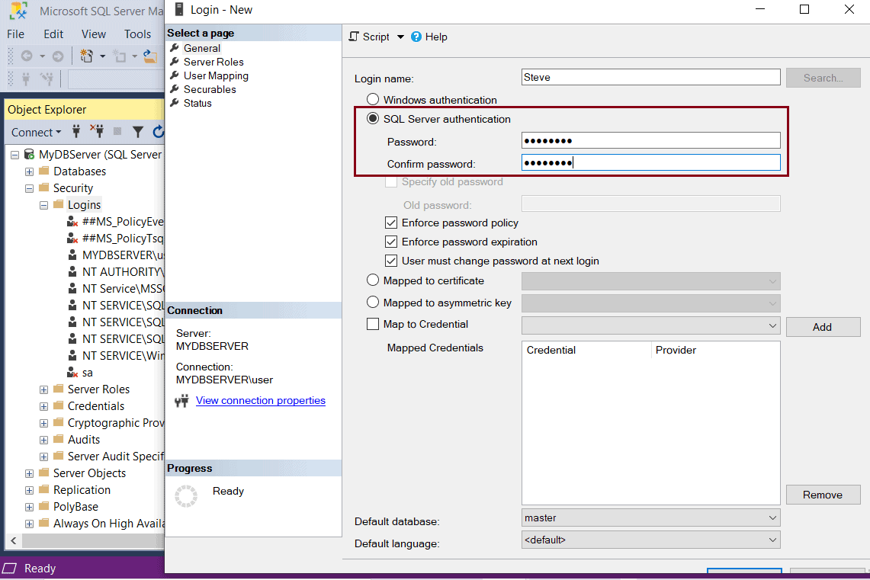](https://www.tutorialsteacher.com/Content/images/sqlserver/authentication9.png)SQL Server Authentication

Select three optional password policies:

* **Enforce password policy:** The Windows password policies of the computer are enforced for SQL Server Logins.
* **Enforce password expiration:** The maximum password age policy of the computer is enforced.
* **User must change password at next login:** If this option is selected, the user is required to change their SQL Server login password the next time they login.

Select the Server Roles tab. In the new window, assign a server-level role to the login being created. By default, public is selected. You can add any role to the login by selecting the checkbox next to the role. In the figure below, sysadmin is selected along with public. With sysadmin server role, user can perform any activity on the server and has full control.

[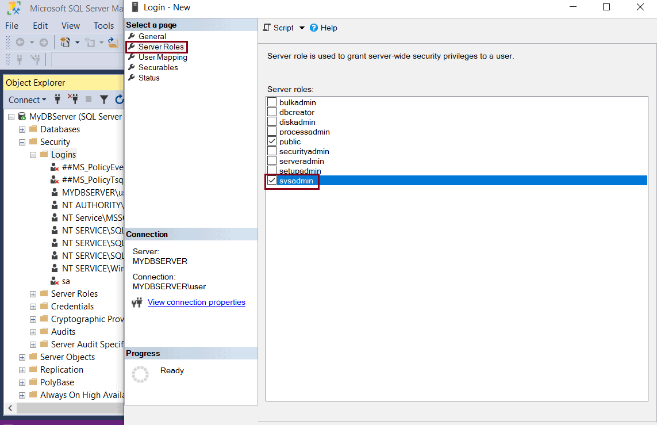](https://www.tutorialsteacher.com/Content/images/sqlserver/authentication10.png)SQL Server Authentication Modes

Click on User mapping tab. You can create a user to a database while creating a new login under user mapping tab. In the new window, a list of all databases in the server instance is displayed. Select the database(s) for which you want to map the login. You can select multiple databases. Just select the check box next to the database name. The login name is now displayed in the User column, next to the selected database, as shown below.

[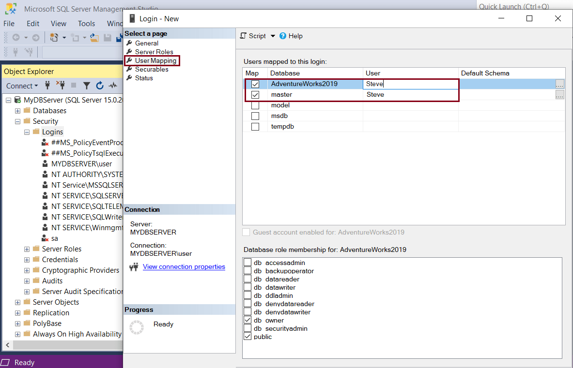](https://www.tutorialsteacher.com/Content/images/sqlserver/authentication11.png)SQL Server Authentication Modes

Click on the Securables tab. In the new window, select the Search button. In the pop-up, select The Server ‘' and click OK. This is an optional step. You may skip this step and set the permissions later.

[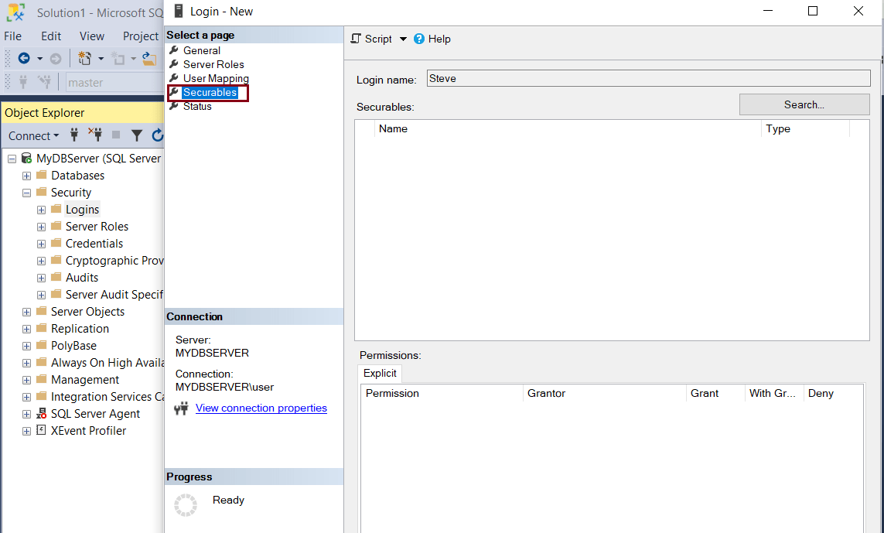](https://www.tutorialsteacher.com/Content/images/sqlserver/authentication14.png)SQL Server Authentication Modes

Finally, check the status screen. Grant and Enabled should be selected.

[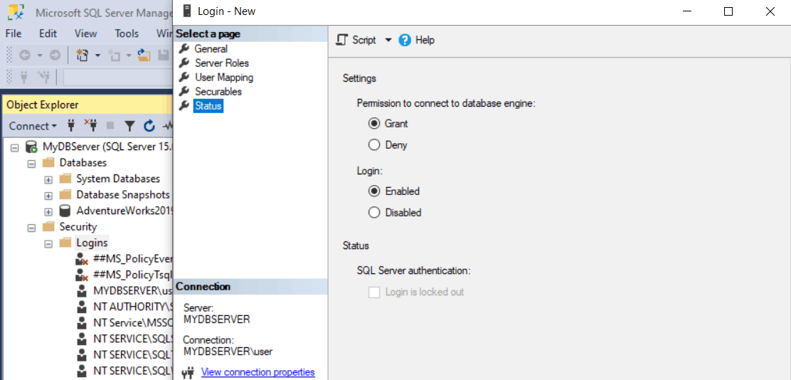](https://www.tutorialsteacher.com/Content/images/sqlserver/authentication15.png)SQL Server Authentication Modes

Click Ok to create the new login. This will add a new SQL Server login under the Logins node, as shown below.

[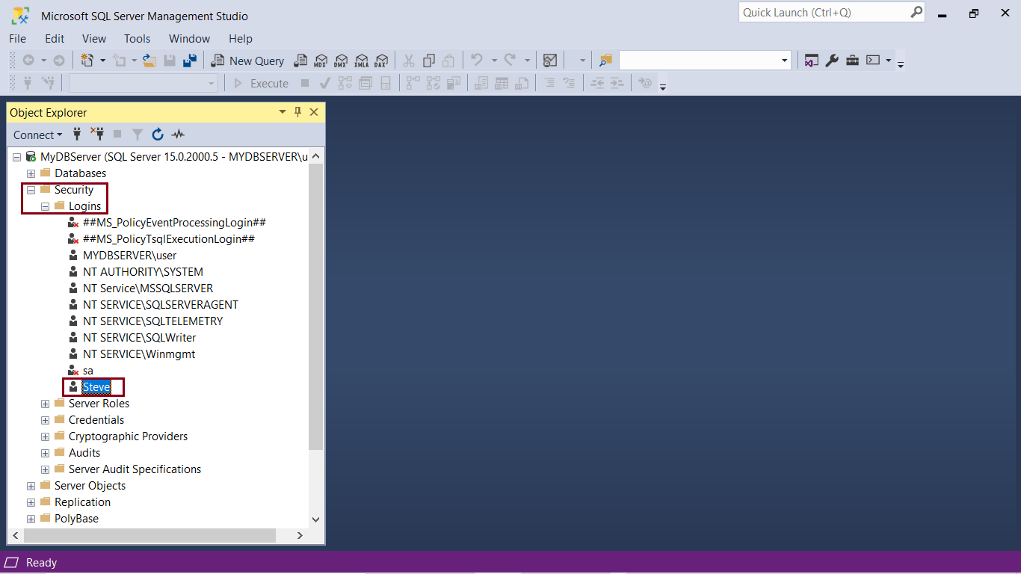](https://www.tutorialsteacher.com/Content/images/sqlserver/authentication12.png)SQL Server Authentication Modes

You can now login to SQL Server SSMS with the new login:

[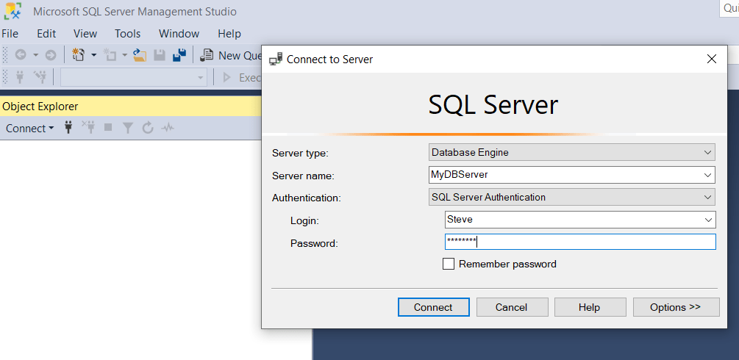](https://www.tutorialsteacher.com/Content/images/sqlserver/authentication13.png)SQL Server Authentication Modes

### Advantages of SQL Server Authentication:

* Allows SQL Server to support older applications and applications built on mixed OS.
* Allows access to web-based applications where users create their own identities.
* Allows users to connect from unknown domains.

### Disadvantages of SQL Server Authentication

* Users using Windows must provide an additional set of login/password to connect to SQL Server.
* SQL Server authentication cannot use Kerberos security protocol.
* Windows offers additional password policies that are not available for SQL Server logins.
* For many applications, login and password have to be passed over the network during connection to the database server. Though encrypted, these are vulnerable to attacks.
* Some applications store the encrypted password in the client system. This is an added security risk.

### Trouble shoot

If you get an error while using a new SQL Server login, then check the following:

1. Enable Mixed mode authentication (SQL Server authentication & Windows authentication) in SQL Server instance property.

Open Management Studio, right-click on the SQL Server instance & click properties. Go to Security tab.

Under Server Authentication, check SQL Server and Windows Authentication Mode radio button, as shown below.

[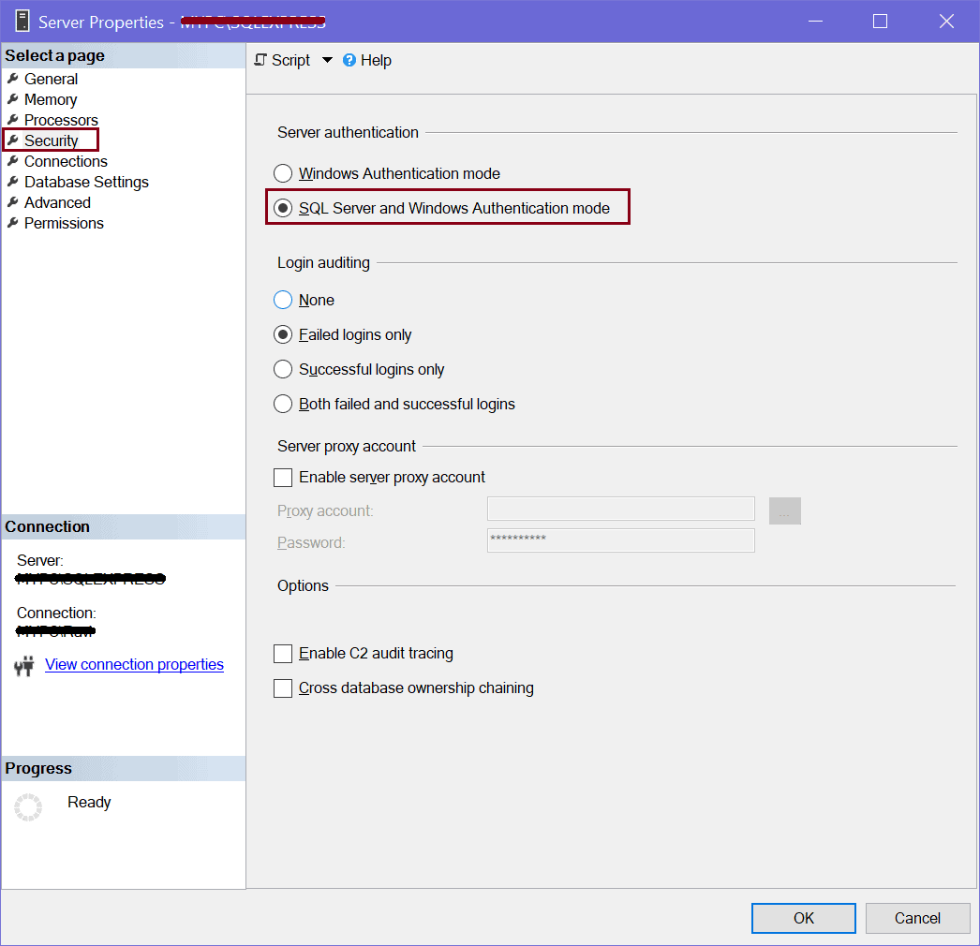](https://www.tutorialsteacher.com/Content/images/sqlserver/authentication16.png)

2. Check if TCP/IP protocol is enabled. Restart SQL Server.

3. Sometimes having the password expiration check box selected gives an error when you try to login with the new login. You can try creating a login with Password Expiration unchecked.